**Output: 1 Thread**

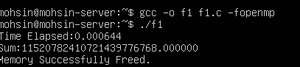

**Output: 2 Thread**

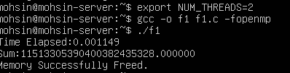

**Output: 4 Thread**

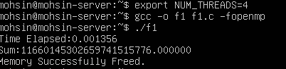

**Output: 8 Thread**

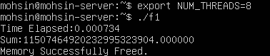

**Output: 10 Thread**

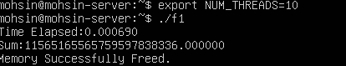

**Output: 20 Thread**

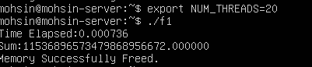

**Output: 100 Thread**

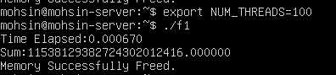

**Output: 200 Thread**

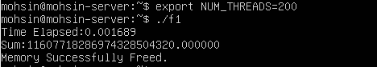

**Solution To The Question:**

**#pragma omp single or #pragma omp parallel num_threads(1)**